Descriptive analysis MatchBoots

## Table 1 parameters

Estimated transformation parameter   
 bnch$time   
-0.01031304

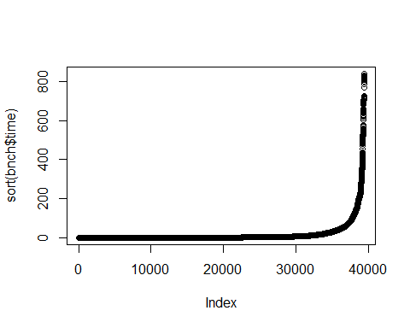

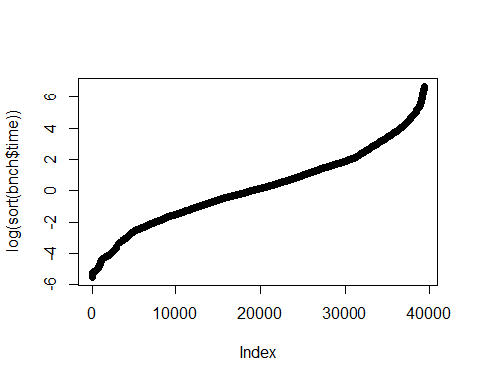

| **Characteristic** | **100**, N = 7,100*1* | **200**, N = 7,100*1* | **1000**, N = 5,670*1* | **2000**, N = 5,670*1* | **10000**, N = 4,230*1* | **20000**, N = 4,230*1* | **1e+05**, N = 2,680*1* | **2e+05**, N = 2,680*1* |
| --- | --- | --- | --- | --- | --- | --- | --- | --- |
| Algorithm |  |  |  |  |  |  |  |  |
| Naive | 1,190 (17%) | 1,190 (17%) | 950 (17%) | 950 (17%) | 710 (17%) | 710 (17%) | 460 (17%) | 460 (17%) |
| Hash | 1,190 (17%) | 1,190 (17%) | 950 (17%) | 950 (17%) | 710 (17%) | 710 (17%) | 460 (17%) | 460 (17%) |
| Threshold | 4,720 (66%) | 4,720 (66%) | 3,770 (66%) | 3,770 (66%) | 2,810 (66%) | 2,810 (66%) | 1,760 (66%) | 1,760 (66%) |
| Additional candidate matches proportion |  |  |  |  |  |  |  |  |
| 0.1 | 1,440 (20%) | 1,440 (20%) | 1,440 (25%) | 1,440 (25%) | 1,440 (34%) | 1,440 (34%) | 1,340 (50%) | 1,340 (50%) |
| 2 | 1,440 (20%) | 1,440 (20%) | 1,440 (25%) | 1,440 (25%) | 1,440 (34%) | 1,440 (34%) | 1,340 (50%) | 1,340 (50%) |
| 10 | 1,440 (20%) | 1,440 (20%) | 1,440 (25%) | 1,440 (25%) | 1,350 (32%) | 1,350 (32%) | 0 (0%) | 0 (0%) |
| 100 | 1,440 (20%) | 1,440 (20%) | 1,350 (24%) | 1,350 (24%) | 0 (0%) | 0 (0%) | 0 (0%) | 0 (0%) |
| 1000 | 1,340 (19%) | 1,340 (19%) | 0 (0%) | 0 (0%) | 0 (0%) | 0 (0%) | 0 (0%) | 0 (0%) |
| Threshold to use |  |  |  |  |  |  |  |  |
| 1 | 1,180 (25%) | 1,180 (25%) | 950 (25%) | 950 (25%) | 710 (25%) | 710 (25%) | 440 (25%) | 440 (25%) |
| half | 1,180 (25%) | 1,180 (25%) | 940 (25%) | 940 (25%) | 700 (25%) | 700 (25%) | 440 (25%) | 440 (25%) |
| max | 1,180 (25%) | 1,180 (25%) | 940 (25%) | 940 (25%) | 700 (25%) | 700 (25%) | 440 (25%) | 440 (25%) |
| double | 1,180 (25%) | 1,180 (25%) | 940 (25%) | 940 (25%) | 700 (25%) | 700 (25%) | 440 (25%) | 440 (25%) |
| Unknown | 2,380 | 2,380 | 1,900 | 1,900 | 1,420 | 1,420 | 920 | 920 |
| Matching rules and Variable distributions |  |  |  |  |  |  |  |  |
| Age exact + Uniform | 2,400 (34%) | 2,400 (34%) | 1,920 (34%) | 1,920 (34%) | 1,440 (34%) | 1,440 (34%) | 960 (36%) | 960 (36%) |
| Age +=1 + Uniform | 2,400 (34%) | 2,400 (34%) | 1,920 (34%) | 1,920 (34%) | 1,440 (34%) | 1,440 (34%) | 960 (36%) | 960 (36%) |
| Age exact + Normal | 2,300 (32%) | 2,300 (32%) | 1,830 (32%) | 1,830 (32%) | 1,350 (32%) | 1,350 (32%) | 760 (28%) | 760 (28%) |
| Sampling of candidate matches and bootstrap schema |  |  |  |  |  |  |  |  |
| Sample 1 cm to each exposed | 1,800 (25%) | 1,800 (25%) | 1,440 (25%) | 1,440 (25%) | 1,080 (26%) | 1,080 (26%) | 720 (27%) | 720 (27%) |
| Take all cm to each exposed | 1,740 (25%) | 1,740 (25%) | 1,380 (24%) | 1,380 (24%) | 1,020 (24%) | 1,020 (24%) | 600 (22%) | 600 (22%) |
| Sample 1 cm to each exposed and take 10 bootstrap sampling from the exposed | 1,800 (25%) | 1,800 (25%) | 1,440 (25%) | 1,440 (25%) | 1,080 (26%) | 1,080 (26%) | 720 (27%) | 720 (27%) |
| Sample 1 cm to each exposed and take 10 bootstrap sampling from all UoO | 1,760 (25%) | 1,760 (25%) | 1,410 (25%) | 1,410 (25%) | 1,050 (25%) | 1,050 (25%) | 640 (24%) | 640 (24%) |
| Number of cores used |  |  |  |  |  |  |  |  |
| Use 1 thread | 3,600 (51%) | 3,600 (51%) | 2,880 (51%) | 2,880 (51%) | 2,160 (51%) | 2,160 (51%) | 1,440 (54%) | 1,440 (54%) |
| Use half the threads present in the CPU | 3,500 (49%) | 3,500 (49%) | 2,790 (49%) | 2,790 (49%) | 2,070 (49%) | 2,070 (49%) | 1,240 (46%) | 1,240 (46%) |
| *1*n (%) | | | | | | | | |

## Table 1 metrics

| **Characteristic** | **100**, N = 7,100 | **200**, N = 7,100 | **1000**, N = 5,670 | **2000**, N = 5,670 | **10000**, N = 4,230 | **20000**, N = 4,230 | **1e+05**, N = 2,680 | **2e+05**, N = 2,680 |
| --- | --- | --- | --- | --- | --- | --- | --- | --- |
| Time (s) (Min, Max) | 0 / 12 | 0 / 22 | 0 / 47 | 0 / 90 | 0 / 104 | 0 / 158 | 3 / 374 | 9 / 840 |
| Time (s) (25%, Median, 75%) | 0 / 0 / 1 | 0 / 0 / 1 | 0 / 1 / 3 | 0 / 1 / 4 | 1 / 2 / 6 | 2 / 5 / 9 | 13 / 27 / 57 | 44 / 97 / 198 |
| Time (s) (Mean, SD) | 1 / 1 | 1 / 2 | 3 / 6 | 4 / 10 | 7 / 13 | 10 / 15 | 46 / 49 | 149 / 158 |
| Memory allocation (MB) (Min, Max) | 1 / 2,525 | 1 / 9,414 | 2 / 14,803 | 2 / 35,887 | 17 / 24,652 | 63 / 51,740 | 1,463 / 145,964 | 5,206 / 435,885 |
| Memory allocation (MB) (25%, Median, 75%) | 7 / 22 / 55 | 9 / 32 / 101 | 24 / 65 / 202 | 42 / 119 / 425 | 194 / 527 / 1,083 | 510 / 1,210 / 3,178 | 5,708 / 14,982 / 31,040 | 21,992 / 53,122 / 115,457 |
| Memory allocation (MB) (Mean, SD) | 67 / 221 | 174 / 800 | 353 / 1,393 | 765 / 3,356 | 1,308 / 2,890 | 3,131 / 6,126 | 23,447 / 24,982 | 83,413 / 84,908 |
| Secondary memory usage (KB) (Min, Max) | 0 / 564 | 1 / 1,094 | 5 / 2,245 | 13 / 3,342 | 80 / 5,240 | 154 / 12,029 | 806 / 176,312 | 1,604 / 750,538 |
| Secondary memory usage (KB) (25%, Median, 75%) | 9 / 28 / 72 | 15 / 44 / 126 | 61 / 134 / 358 | 124 / 279 / 616 | 706 / 1,127 / 2,130 | 1,381 / 2,857 / 4,344 | 4,790 / 14,312 / 19,207 | 9,194 / 28,152 / 36,002 |
| Secondary memory usage (KB) (Mean, SD) | 68 / 97 | 121 / 182 | 309 / 444 | 501 / 629 | 1,503 / 1,174 | 3,023 / 2,357 | 25,408 / 37,365 | 90,488 / 163,945 |

## Algorithm

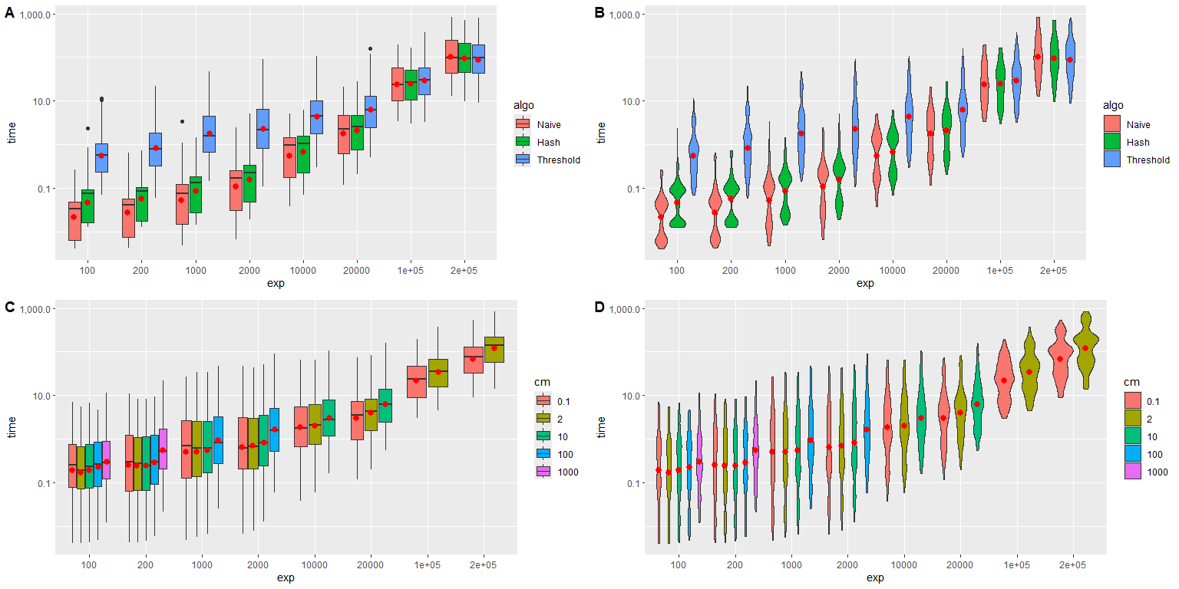

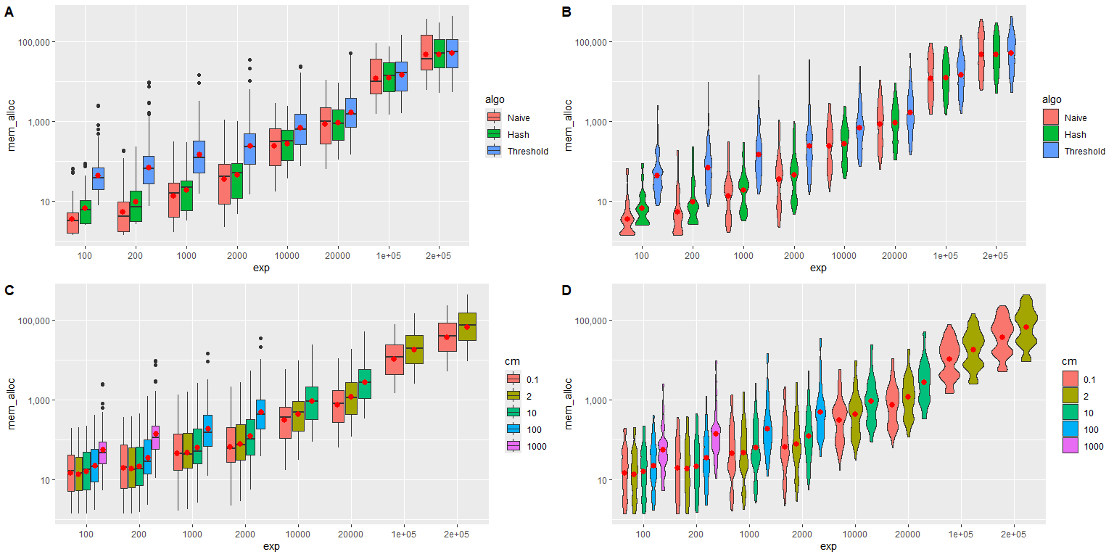

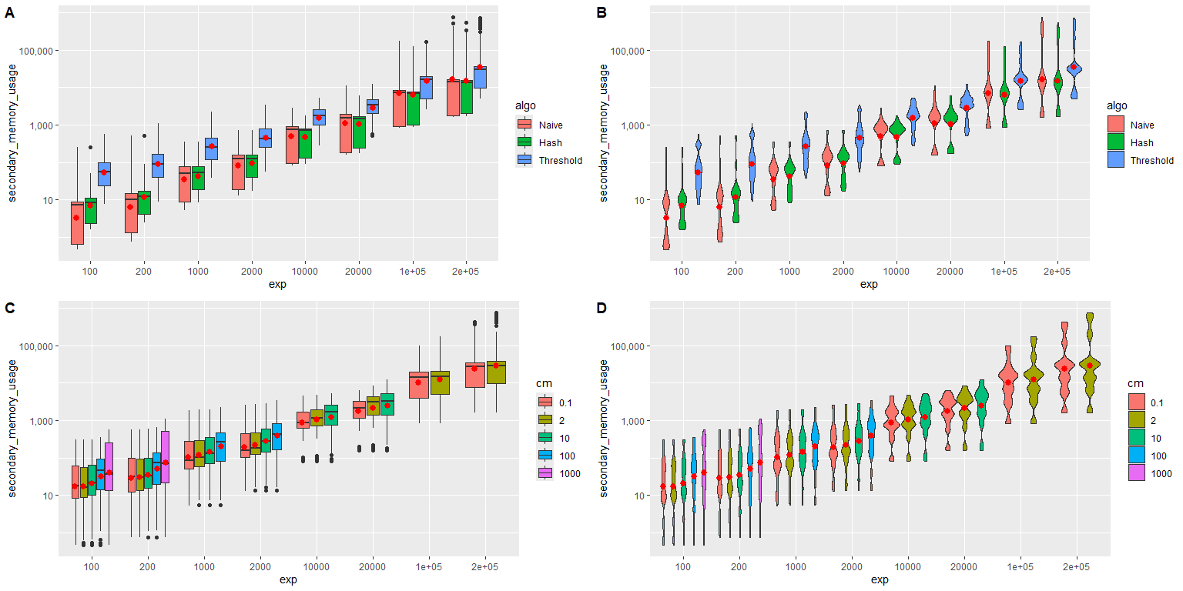

## Candidate matches

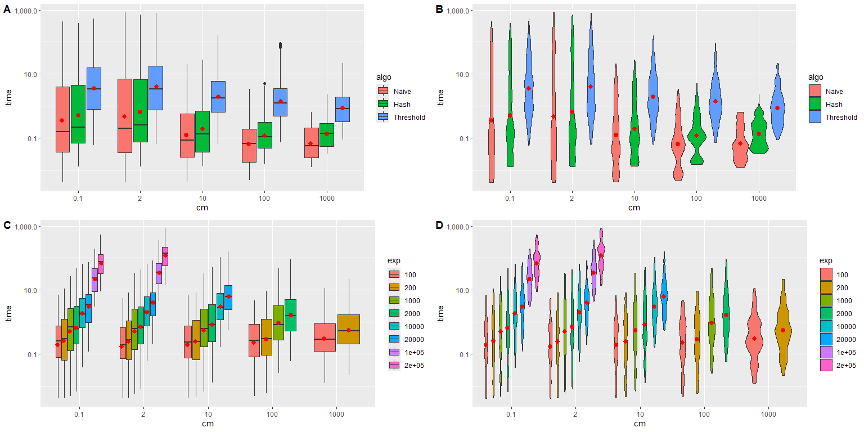

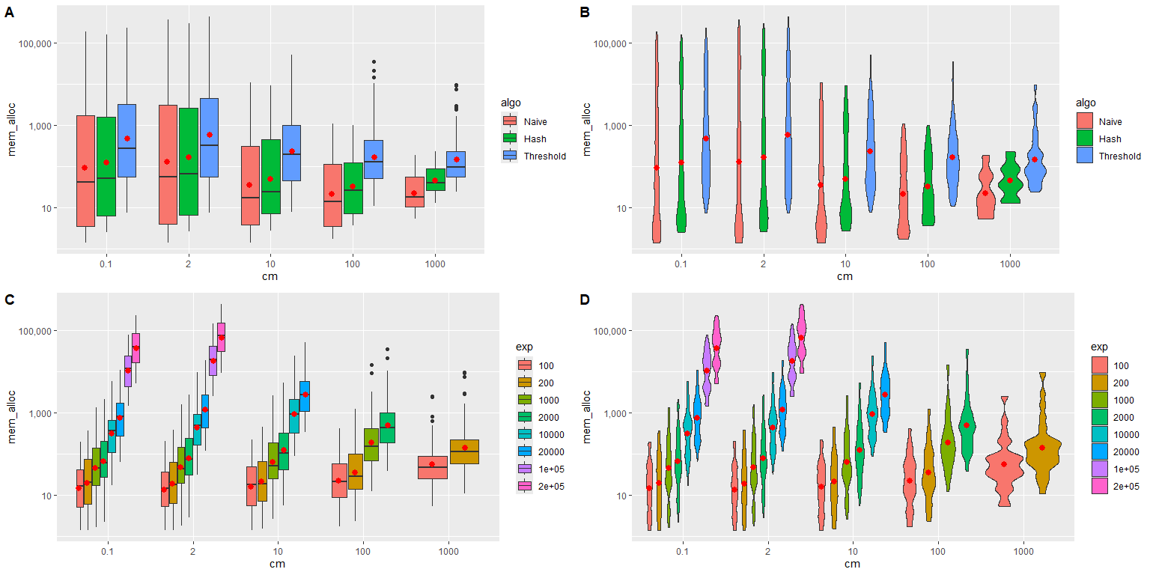

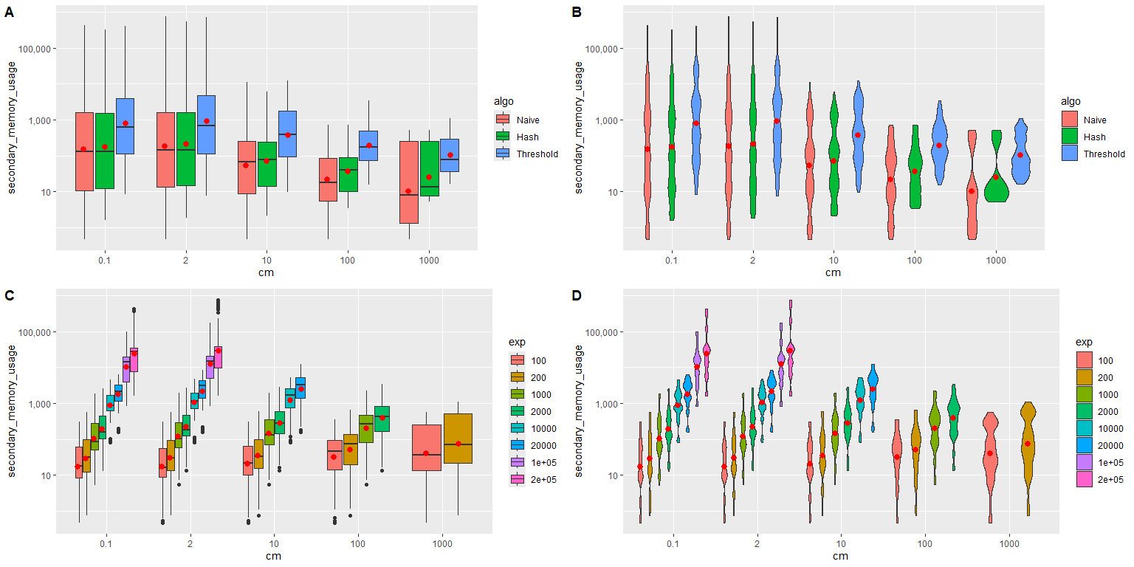

## Threshold to use

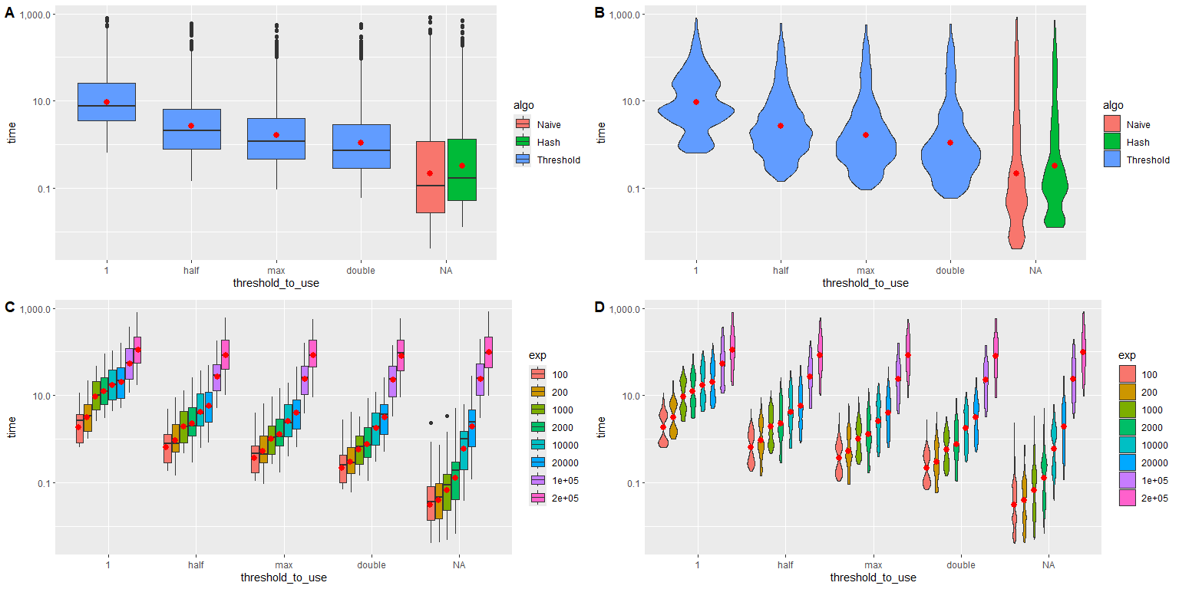

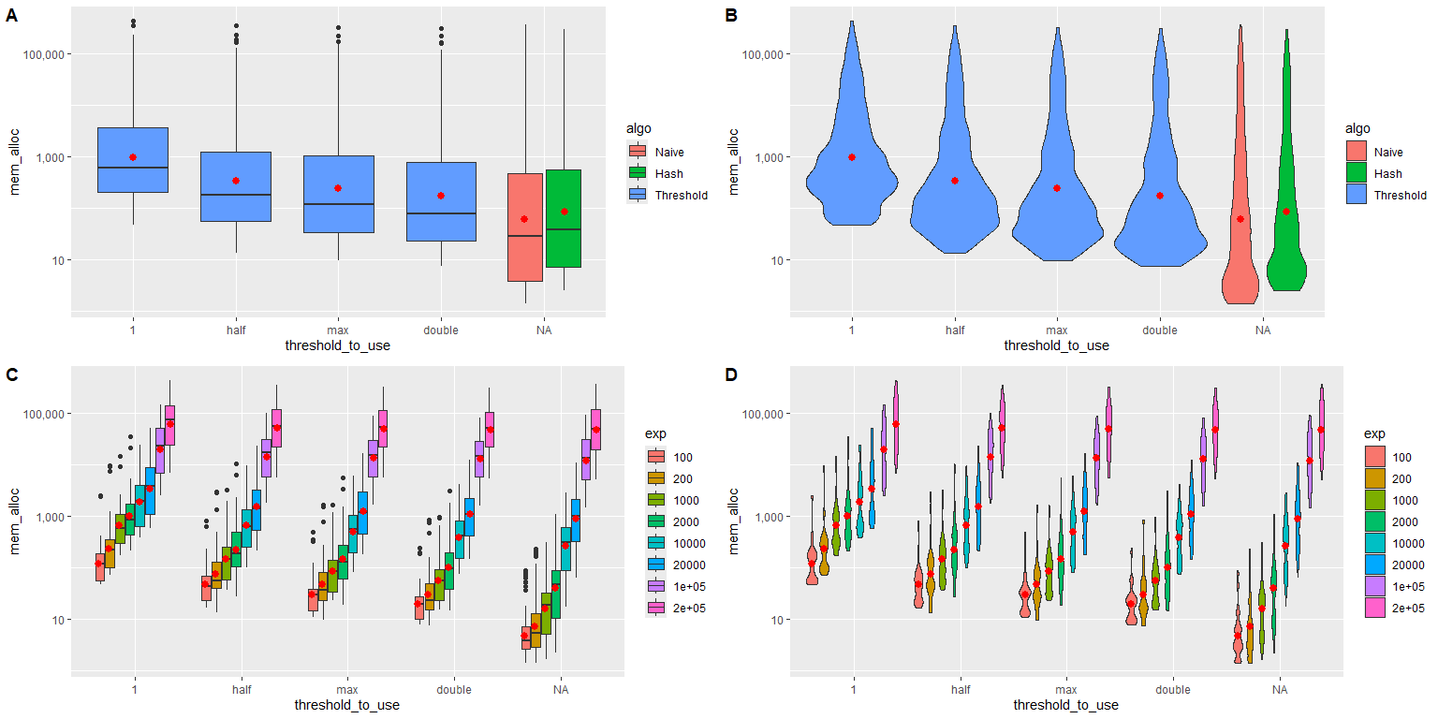

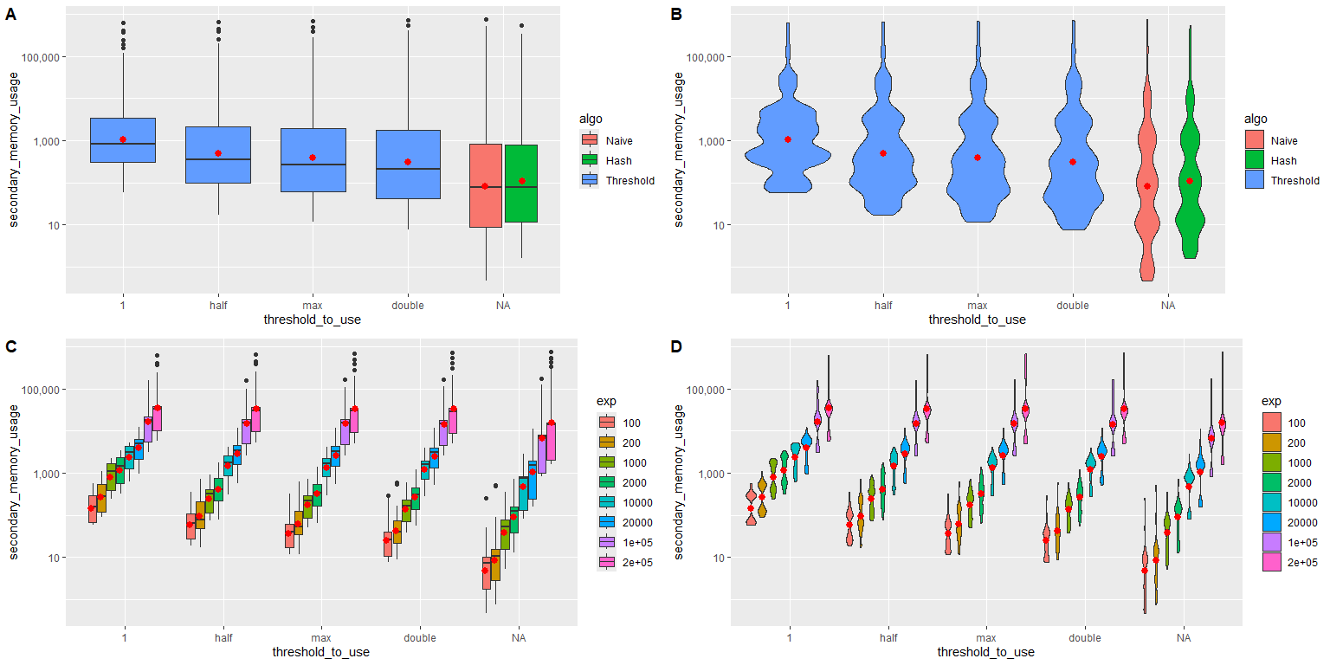

## Matching rules and Variable distributions

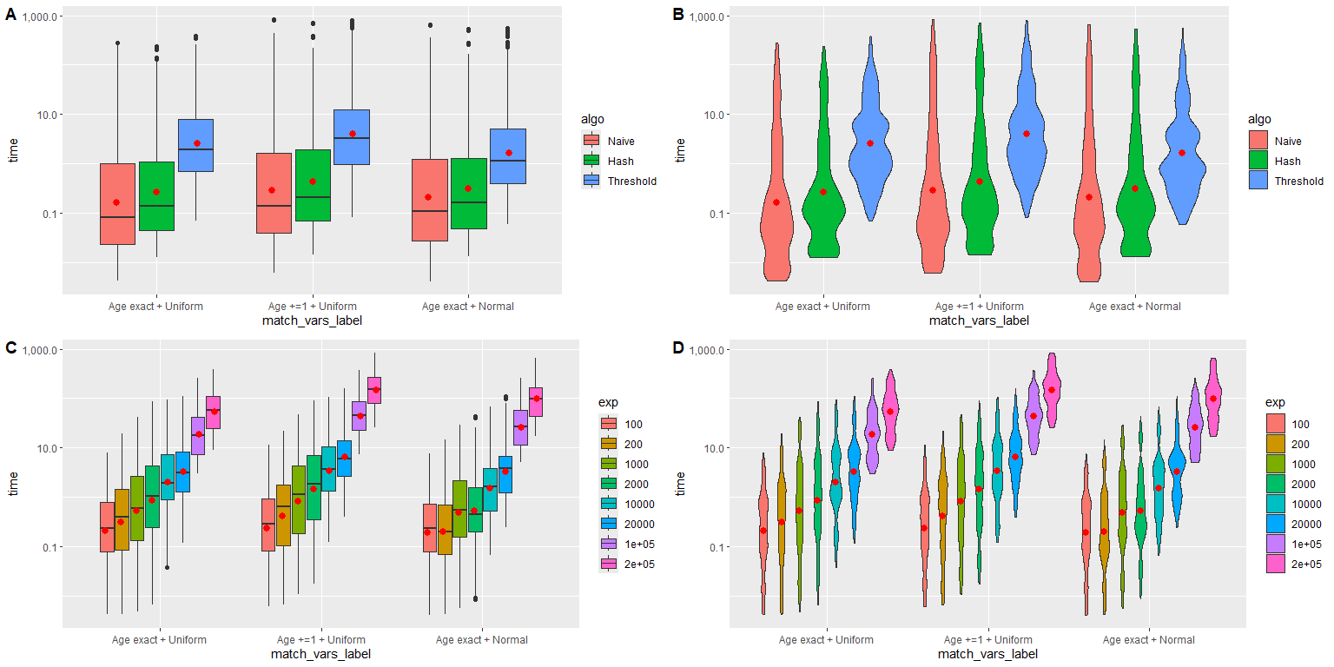

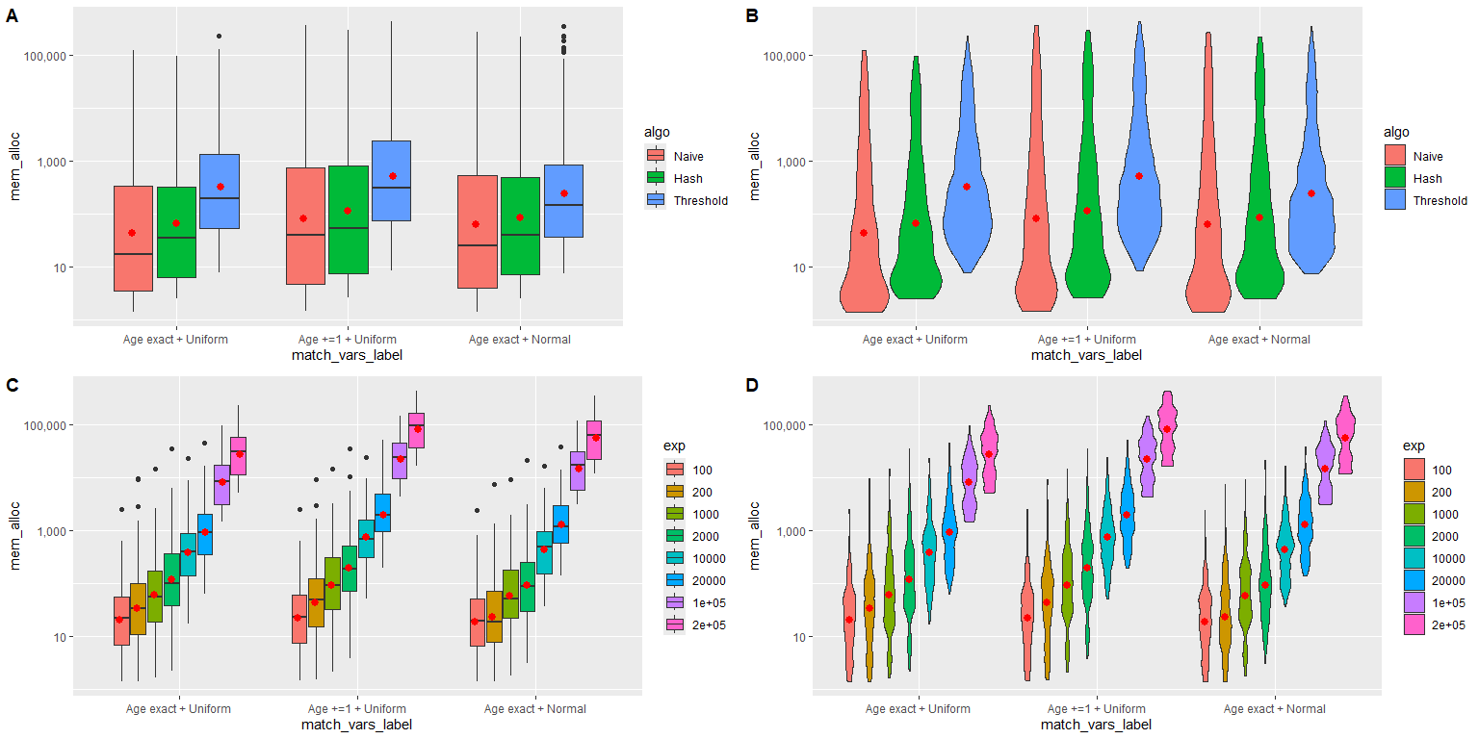

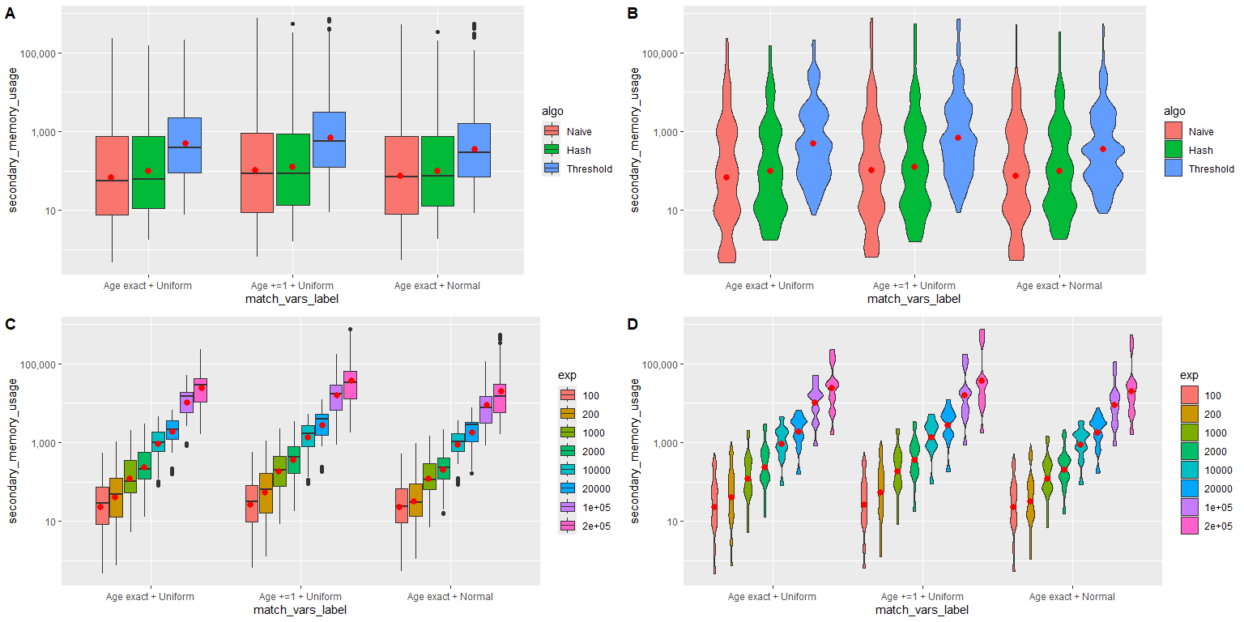

## Sampling of candidate matches and bootstrap schema

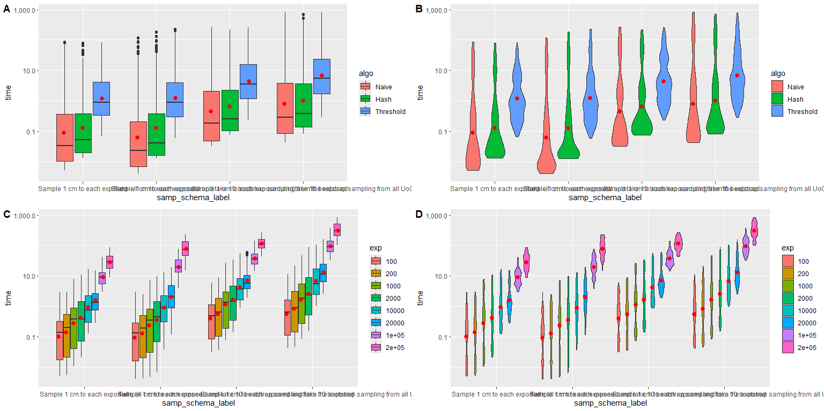

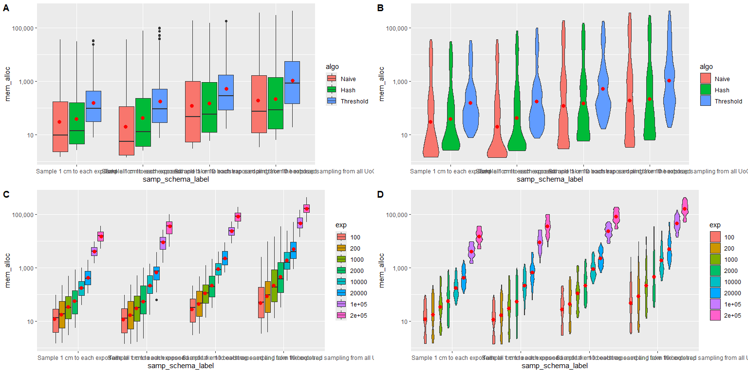

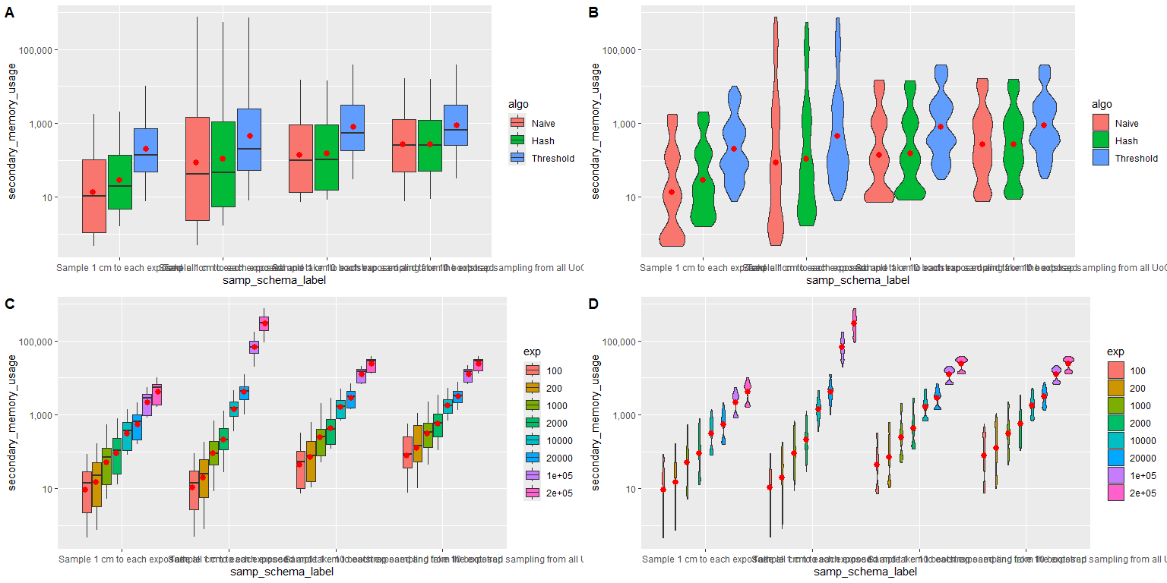

## Number of cores used

